1. **Explain what is Xcode?**

Xcode is an IDE for macOS containing a suite of software development tools developed by Apple for developing software for macOS,iOS, iPadOS, watchOS, and tvOS.

1. **Explain how you can add frameworks in Xcode project?**

To add Frameworks in Xcode project from the navigator select the project. Then in the Project settings editor select the target for where you want to add framework, then Build Phases Tab and click “Link Binaries with Libraries”. After this click the “+” button to get the list of all available frameworks and select the framework you want to add in Project.

1. **Explain what is the difference between Xcode, Cocoa and Objective C?**

Xcode is the IDE that gives you ability to code, debug, test, profile and ship your applications for Mac, iOS, tvOS, watchOS.

Objective C is a programming Language that lets a developer write code and make different types of programs.

Cocoa is a framework which provides pre-built functions, Data Structures and Functionalities to the Developer so that he/she don’t have to write everything on their own(re-inventing the wheel). It helps in reducing Development time.

1. **What is the short cut to open the “Code Snippet Library” in Xcode?**

The Shortcut to open Code Snippet library is “cmd+Shift+L”

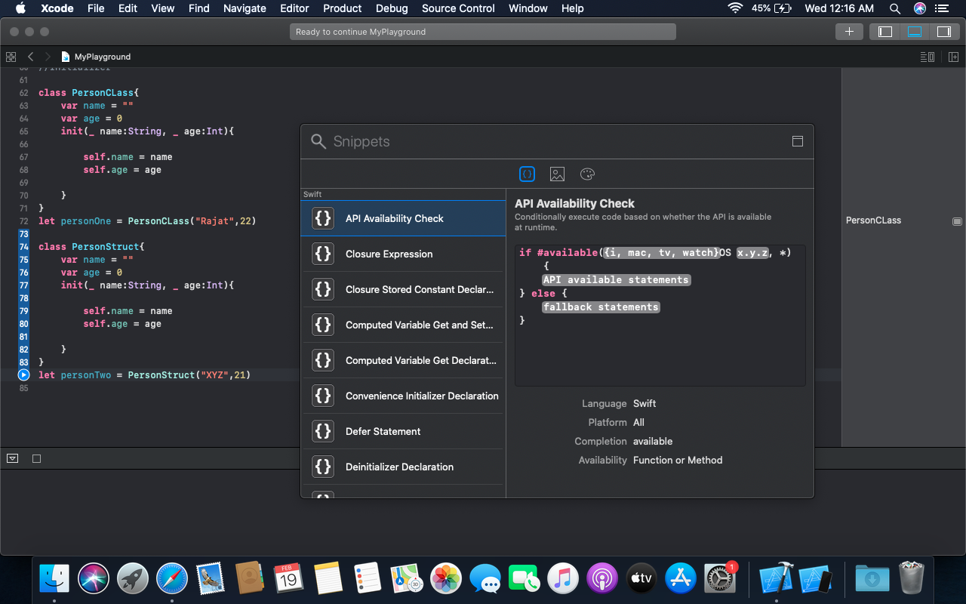

1. **Mention what are the build phases available in Xcode?**

There are 4 build phases in Xcode

1. Dependencies
2. Compile Sources
3. Link Binary with Libraries
4. Copy Bundle resoources

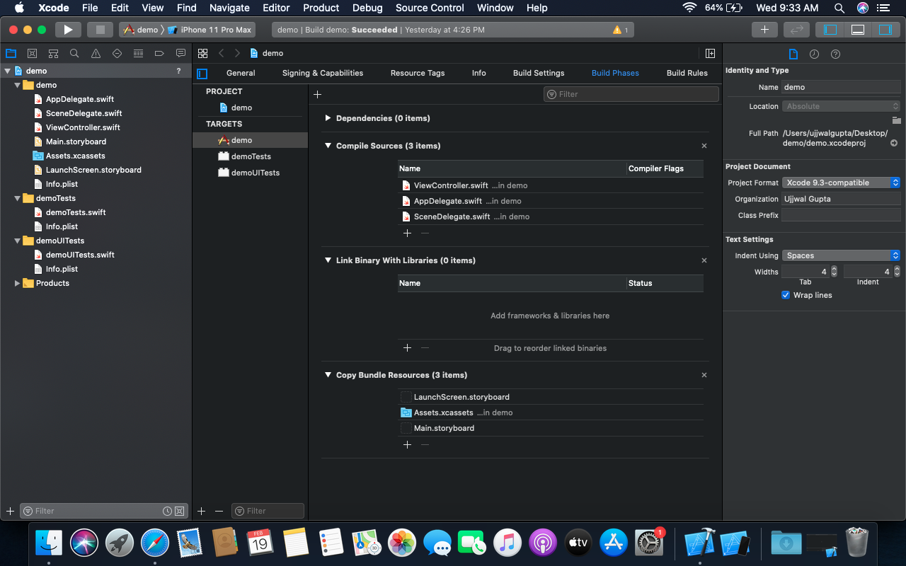

1. **Explain how app delegate is declared by Xcode project templates?**

App delegate is declared as a subclass of UIResponder by Xcode project templates.

1. **Explain how you define variables in Swift language?**

There are 4 parts in defining a variable in swift - keyword,variable name, variable type, value

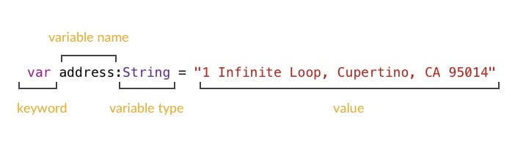

1. **What is interface builder?**

Interface Builder allows developers to create interfaces for applications using a graphical user interface (GUI). Interface Builder is the part where you lay out the graphical interface of your program—the buttons, toolbars, menus, images, and text that make up how your users interact with your program.

1. **Create an app with a login interface which should have two text field for email, password where the password is a secure field and a button.**

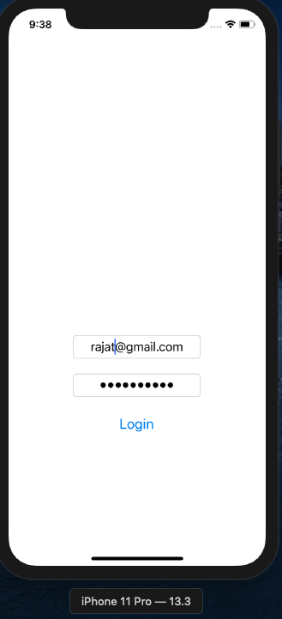

1. **List devices and their resolutions, screen size has iOS as their OS.**

iPhone 2G,3G,3GS - 320 × 480 pixels

iPhone 4,4s - 640 × 960 pixels

iPhone 5, 5s, 5c, SE - 640×1136 pixels

iPhone 6,6s,7,8 - 750 × 1334 pixels

iPhone 6+,6s+,7+,8+ - 1242 × 2208 pixels

iPhone 11pro,X,Xs - 1125 × 2436 pixels

iPone 11,XR - 828 × 1792 pixels

iPhone 11Pro Max,Xs Max - 1242 × 2688

